Deutsch 101 Name:
Arbeitsblatt für Tag 8: Practice Test Kapitel 1 fällig am Tag 8 des Kurses

This practice test is the same format as the test you will take in class; you can use it as a study guide, and the answers are provided for you on our class webpage. Make sure to learn your vocabulary and be able to conjugate the verbs ‘sein’ and ‘haben’ as well as the other information provided here for your practice!

A. Listening: Spelling. On the test, your instructor will spell three words in German for you to write down.

1. http://www.nthuleen.com/mc/101/hw/ab8-spelling-1.mp3 =
2. http://www.nthuleen.com/mc/101/hw/ab8-spelling-2.mp3 =
3. http://www.nthuleen.com/mc/101/hw/ab8-spelling-3.mp3 =

B. Listening: How Many? There will be a second listening comprehension section dealing with numbers; there’s no example to practice at home but be sure you understand spoken numbers in German. You may wish to visit http://www.languageguide.org/german/numbers/ to practice understanding numbers!

C. Greetings and Farewells. Find the appropriate German greeting to match each situation.

1. You ask your professor how they are doing. A. Wie geht’s?
2. You ask a close friend how it’s going. B. Mahlzeit!
3. You answer that you’re not doing too well. C. Mir geht es nicht so gut.
4. Around 7pm, you greet the cashier at the cafeteria. D. Guten Tag!
5. You greet a co-worker in the morning. E. Guten Morgen!
6. Around 2:00 pm, you greet the clerk in a small shop. F. Gute Nacht!
7. You head upstairs to go to bed at night. G. Auf Wiedersehen!
8. You run into a friend of yours in Southern Germany or Austria. H. Schönen Tag noch!
9. You say goodbye as you leave a job interview. I. Grüß dich!
10. You want to tell your friend that you’ll see them tomorrow. J. Wie geht es Ihnen?
11. You say goodbye and tell your co-workers to have a nice day. K. Guten Abend!
12. As you sit down for lunch in the cafeteria, you might say this. L. Bis morgen!

D. Casual or Formal? Which form of address would you use when speaking to the following people? Write du, Sie or ihr in each blank.

1. your brother:
2. two classmates:
3. two elderly men sitting beside you on a park bench:
4. the six-year old sitting beside you on a park bench:
5. a policemen on the street:
6. your cat:
7. a whole class of first-grade children:
8. two of your professors:
E. Vocabulary: Basic Nouns and Objects. In each blank below, provide the German singular noun plus the definite article (der, die or das). You should practice all the nouns at our Quizlet site https://quizlet.com/211907311/lektion-1a-singular-forms-of-basic-nouns-flash-cards/ and https://quizlet.com/211906816/lektion-1b-classroom-vocabulary-nouns-flash-cards/ .



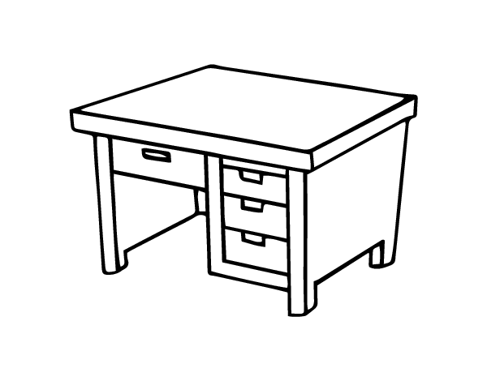
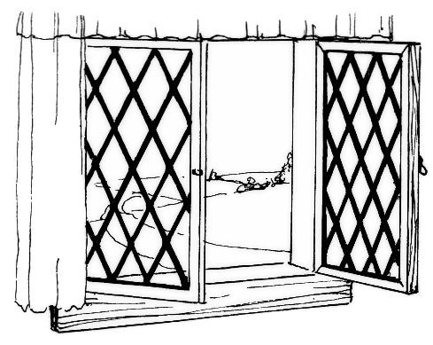
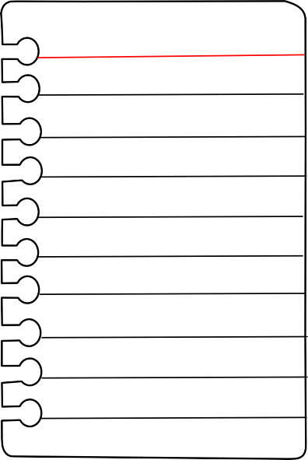
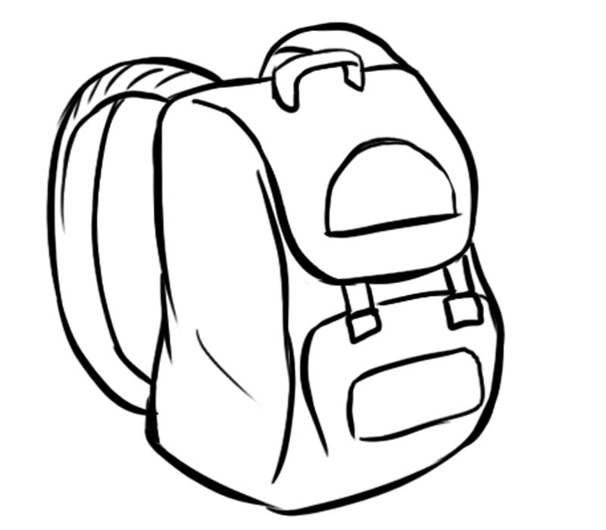




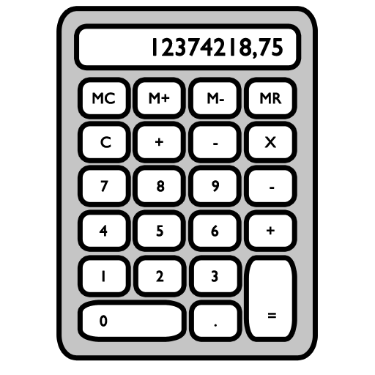
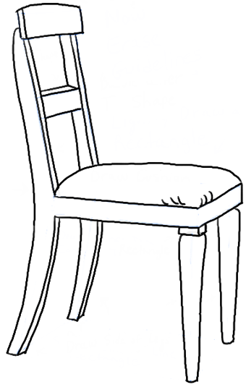


EX. das Buch 7.

1. 8.

2. 9.

3. 10.

4. 11.

5. 12.

6. 13.

F. Plural Forms. For each singular word below, provide the plural form in German. You should practice the plural forms in your book or at Quizlet https://quizlet.com/211907199/lektion-1a-plural-forms-of-basic-nouns-flash-cards/ and https://quizlet.com/211906667/lektion-1b-plural-forms-of-classroom-nouns-flash-cards/ .

EX. die Frau — die Frauen 7. der Mann — die
1. der Professor — die 8. das Buch — die
2. die Professorin — die 9. der Tisch — die
3. der Garten — die 10. das Haus — die
4. das Bild — die 11. der Stuhl — die
5. das Blatt — die 12. die Karte — die
6. der Lehrer — die 13. das Handy — die
G. The Verb “to be” (“sein”). Each sentence below is translated but leaves out the verb ‘to be’. Fill in the blanks with the correct form of the verb to match the subject!

EX. He is my friend. → Er ist mein Freund.
1. I am the teacher. → Ich der Lehrer.
2. You (casual) are a good student. → Du ein guter Schüler.
3. My professor is intelligent. → Mein Professor intelligent.
4. Birgit is a student. → Birgit Studentin.
5. We are here. → Wir hier.
6. You (plural) are very nice. → Ihr sehr nett.
7. Mr. Lehmann, are you (formal) there? → Herr Lehmann, Sie da?
8. The backpacks are big. → Die Rucksäcke groß.

H. Numbers. Write out the spelled German form of the numerals given, and vice-versa, provide the numeral for each spelled-out number.

11:
62:
19:
31:
: siebenundvierzig
: fünfhundertzweiundachtzig
: dreitausendvierhundertsechsundsiebzig

I. Haben and the Accusative Case. Write out each sentence from the clues given. You must provide the correct form of the verb haben as well as the correct article ( ein / einen / eine or der / den / die / das ) in the accusative case for direct objects.

EX. Sophia / haben / ein Kuli (m)
→ Sophia hat einen Kuli.
1. ich / haben / der Ring (m)
→
2. du / haben / ein Computer (m)
→
3. die Lehrerin / haben / die Fotos (pl)
→
4. Rolf / haben / ein Buch (n)
→
5. wir / haben / eine Frage (f)
→
6. ihr / haben / das Papier (n)
→
7. Nina und Klaus / haben / eine Tochter (f)
→
8. das Zimmer / haben / ein Tisch (m)
→

J. Culture: The German School System. Choose the correct term from the list in order to complete each sentence with facts about the German school system.

Abitur • Gesamtschule • Grundschule • Gymnasium • Hauptschule • Kindergarten • Realschule

1. is usually private in Germany, not part of the public school system.
2. Elementary school starts in 1st grade and is called in Germany.
3. Some low-performing students enter the , which ends at age 15.
4. The mid-range ability school is called and prepares students for skilled jobs.
5. The highest-tier school, grades 5-12, for college preparation is called the .
6. A is like American high schools, with students of all levels together.
7. At the end of 12th grade students take the exam to enter university.

K. Reading Comprehension. Laura calls Tom on the phone. Read the transcript of their conversation, then determine if the statements below are TRUE or FALSE.

LAURA: Hallo, Tom, wie geht es dir?
TOM: Hallo, Laura! Es geht mir prima! Heidelberg ist super. Ich habe ein Zimmer hier im
Studentenheim. Und wie geht’s dir?
LAURA: Es geht mir nicht so gut.
TOM: Warum? Was ist los?
LAURA: Ach, mein Zimmer hier in Berlin ist schlecht. Und Berlin ist sehr, sehr groß.
TOM: Hmmm, das tut mir leid. Du, ich bin in der Bibliothek. Ich schreibe dir später eine E-Mail!
LAURA: Hast du meine E-Mail-Adresse?
TOM: Ja, ich habe die Adresse.
LAURA: Gut! Tschüss, Tom.
TOM: Tschüss, Laura. Bis dann.

True or False?
1. Tom is doing very well.
2. Tom has a room in Heidelberg.
3. Laura is doing great.
4. Laura has a room in Berlin.
5. Laura says her room is good.
6. Tom is in the library now.
7. Laura is also in the library.
8. Tom has Laura’s email address.

